Stock prediction:

import numpy as np

import pandas as pd

import matplotlib.pyplot as plt

import seaborn as sb

from sklearn.model_selection import train_test_split

from sklearn.preprocessing import StandardScaler

from sklearn.linear_model import LogisticRegression

from sklearn.svm import SVC

from xgboost import XGBClassifier

from sklearn import metrics

import warnings

warnings.filterwarnings('ignore')

df = pd.read_csv('/content/Tesla.csv')

df.head()

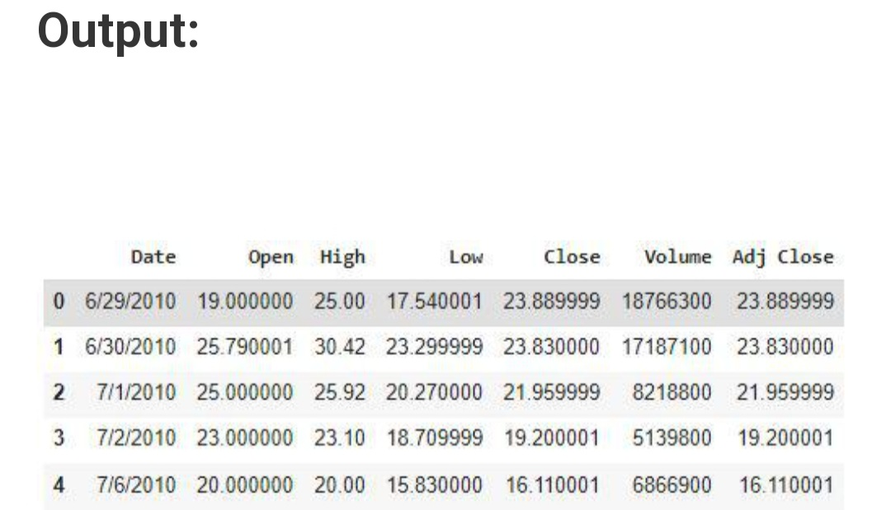

df.shape

Output:

(1692, 7)

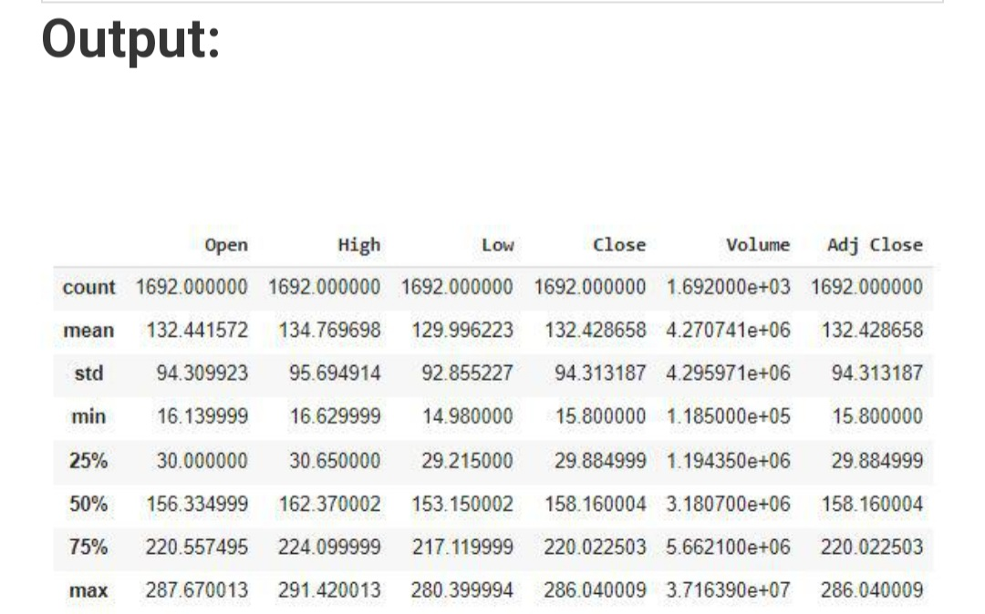

df.info()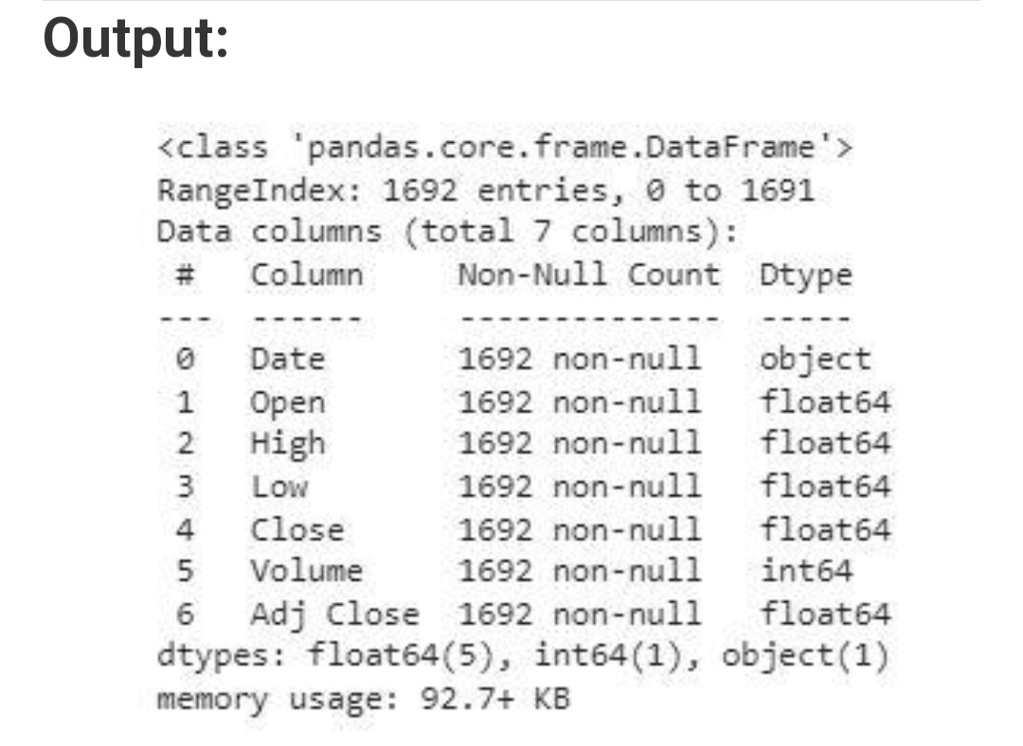

plt.figure(figsize=(15,5))

plt.plot(df['Close'])

plt.title('Tesla Close price.', fontsize=15)

plt.ylabel('Price in dollars.')

plt.show()

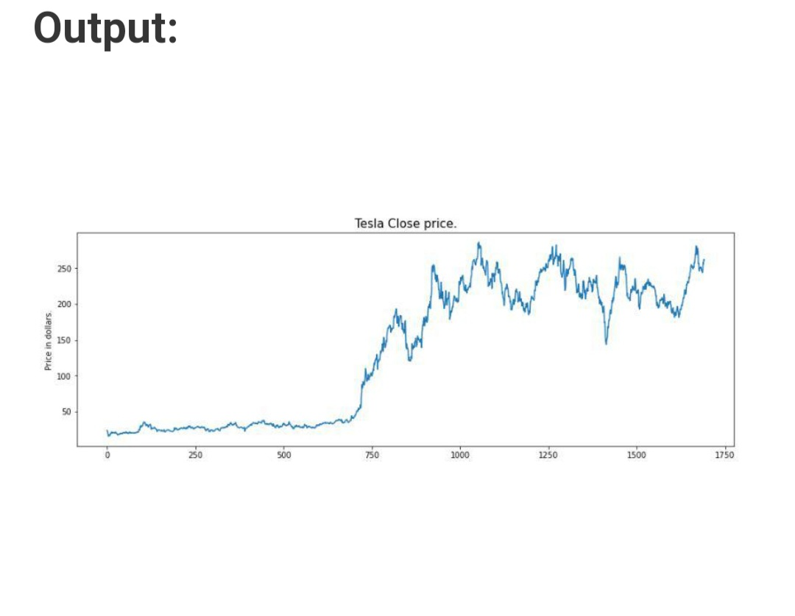

df.head()

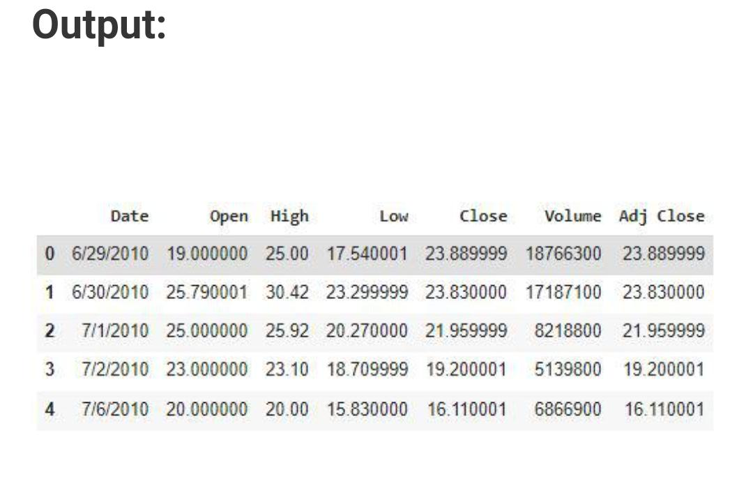

df[df['Close'] == df['Adj Close']

Output:

(1692, 7)

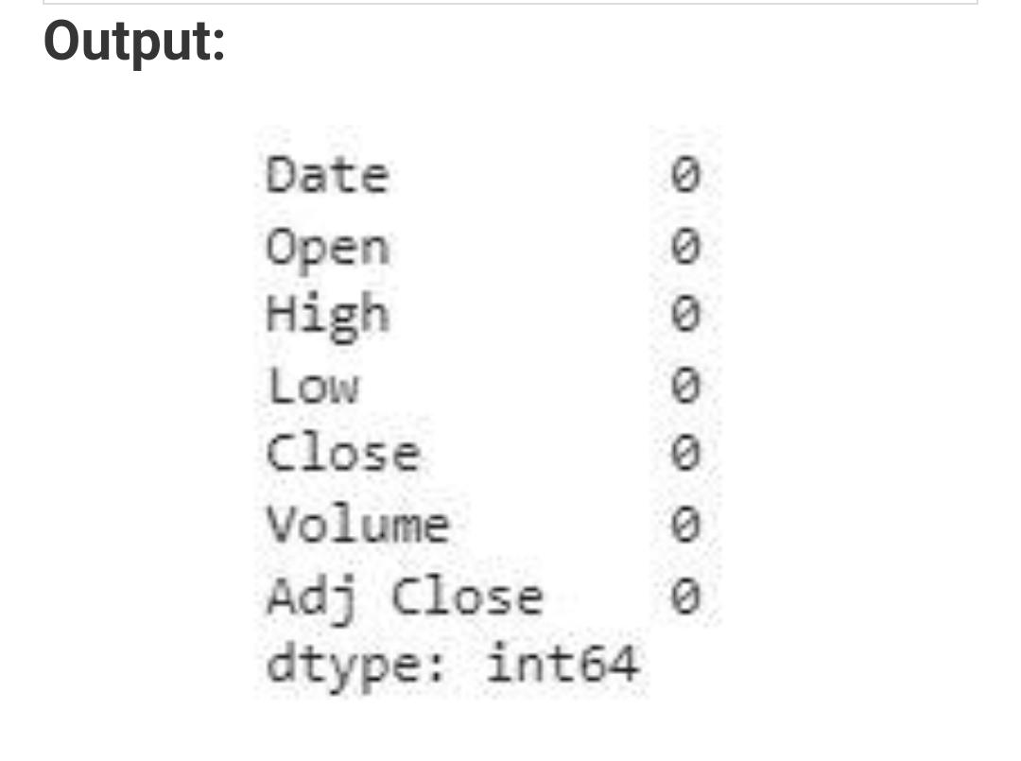

features = ['Open', 'High', 'Low', 'Close', 'Volume']

plt.subplots(figsize=(20,10))

for i, col in enumerate(features):

  plt.subplot(2,3,i+1)

sb.distplot(df[col])

plt.show()

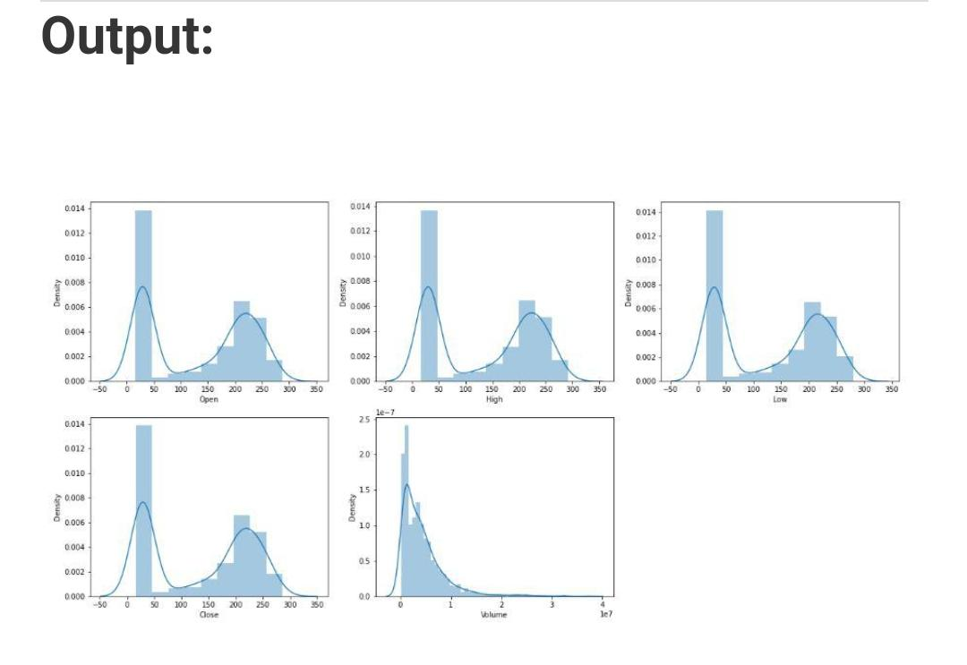

plt.subplots(figsize=(20,10))

for i, col in enumerate(features):

plt.subplot(2,3,i+1)

sb.boxplot(df[col])

plt.show()

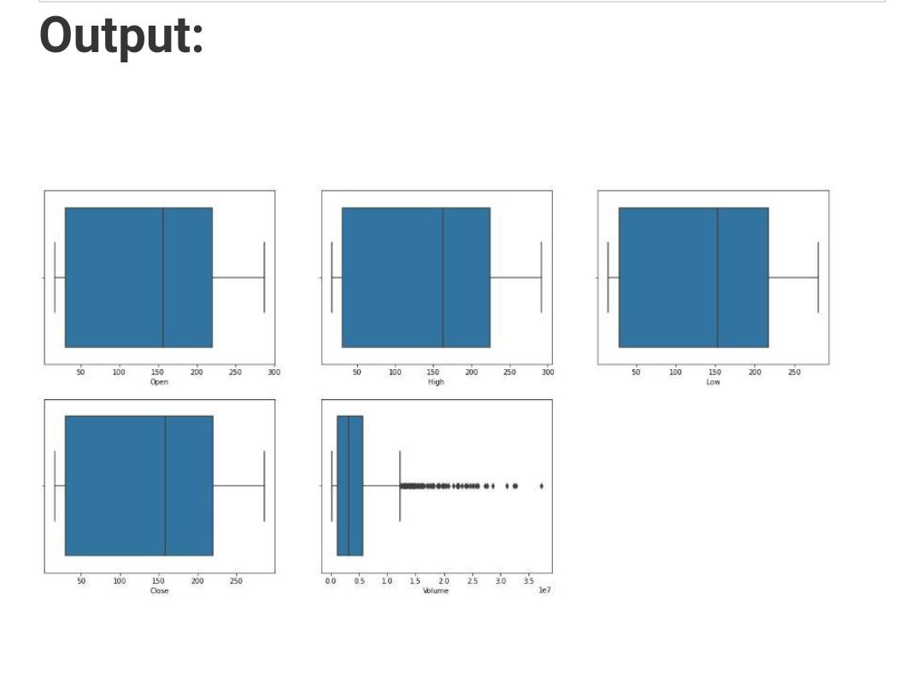

data_grouped = df.groupby('year').mean()

plt.subplots(figsize=(20,10))

for i, col in enumerate(['Open', 'High', 'Low', 'Close']):

plt.subplot(2,2,i+1)

data_grouped[col].plot.bar()

plt.show()

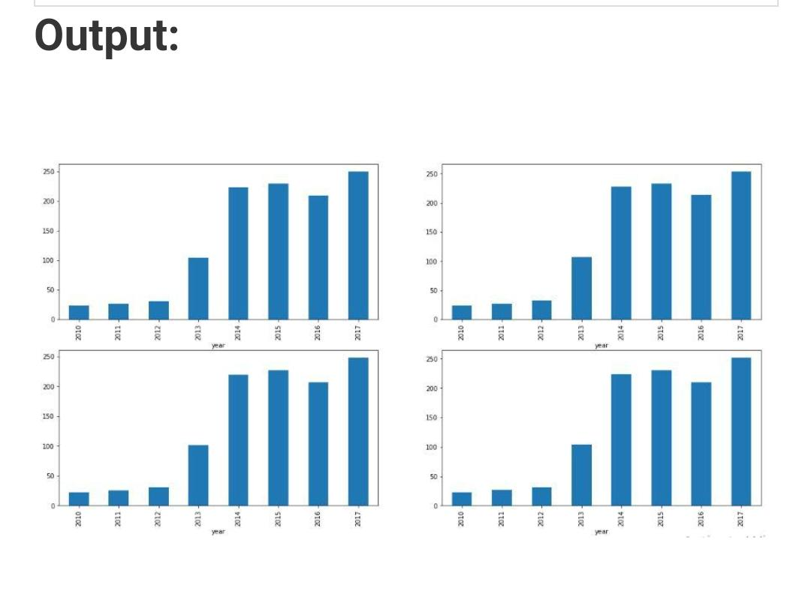

models = [LogisticRegression(), SVC(

kernel='poly', probability=True), XGBClassifier()]

for i in range(3):

models[i].fit(X_train, Y_train)

print(f'{models[i]} : ')

print('Training Accuracy : ', metrics.roc_auc_score(

Y_train, models[i].predict_proba(X_train)[:,1]))

print('Validation Accuracy : ', metrics.roc_auc_score(

Y_valid, models[i].predict_proba(X_valid)[:,1]))

print()

